June

SUNDAY | MONDAY | TUESDAY | WEDNESDAY | THURSDAY | FRIDAY | SATURDAY
Themes  Theme: Making friends week  Fun and Games |  |  | 1  First Day of Camp!  Lunch: Hot dogs/chips | 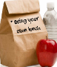  2 | 3  Lunch:  Pizza / drink/dessert | 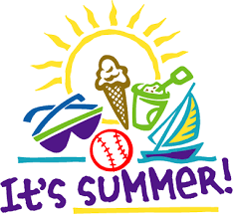  4
5  Water Games | 6 | 7 | 8  Lunch: Hot dogs/chips | 9 | 10  Lunch:  Pizza / drink/dessert | 11
12  Carnival Week | 13 | 14 | 15  Lunch: Hot dogs/chips | 16 | 17  Lunch:  Pizza / drink/dessert | 18
19  Sports Games | 20 | 21 | 22  Lunch: Hot dogs/chips | 23 | 24  Lunch:  Pizza / drink/dessert | 25
26  Community  Helpers | 27 | 28 | 29  Lunch: Hot dogs/chips | 30 | July 1st  Lunch:  Pizza / drink/dessert

Breakfast choices consist of a variety of options such as but not limited to cereal/milk,
pop tarts, toast, juice, fruit.

